**Install Node.js**

Node.js is a programming tool that uses an open sourced command line tool. This tool is built for the java script in Google’s Chrome browser and is mainly used to create websites with push capabilities and build fast network applications. It also has a built-in web server protocol.

Node.js is the JavaScript equivalent to PHP. Node.js can be used to build chatrooms, remotely control programmable electronics, create API’s, build collaborative tools and so much more! This tool is great if you would like to create java applications and it is simple enough to use that a novice coder can create functional programs in hours.

Node.js was not originally built to support Windows 10. To install and run Node.js on Windows 10 perform the following steps:

1. Download Git. Git is a program that allows version control and branches so that it is easy to update and create new objects etc. in the code. You can download Git from their website at:

<https://git-scm.com/book/en/v2/Getting-Started-Git-Basics>

1. Ensure that Git installs properly and then download the latest version of the Node.js .msi Installer that is compatible with the user’s operating system on the node.js website:

<https://nodejs.org/en/download/>

1. Install the setup package from the Node.js website:

<https://nodejs.org/en/>

Once the setup package has been downloaded it will most likely appear at the bottom of the screen.

**Note: The download package for windows is on the website home page. If this is your first time installing the program or you are a novice user choose the package on the left which indicates for most users.**

A screenshot of a cell phone

Description generated with very high confidence

1. Open the installation file and click on **next** and then follow the on screen instructions.

A screenshot of a cell phone

Description generated with very high confidence

**Note: The node package manager is essential to using node. This package manager holds the tools necessary to build applications. If you would like to select the NPM package for the installation select NPM Package Manager on the custom set up screen. This feature requires extra space on your hard drive. Ensure that there is enough space for this package or the installation will fail.**

A screenshot of a social media post

Description generated with very high confidence

1. Verify installation completes by performing all tasks on the on-screen prompts for the installation process. Once you have agreed to all of the parts of the setup the installer will let you know when all of the components have been installed.
2. **Restart** your computer once the program has been completely installed.

**Note: Restarting your computer is essential to the installation process because some components can only be installed when the computer is being restarted.**

1. Click on **Search** at the bottom left corner of your menu bar and type **Command Prompt** after the computer restarts**.** Select the command prompt program from the list and double click on it to open it.

**Note: The command prompt can be found in the system tools menu in the start menu.**

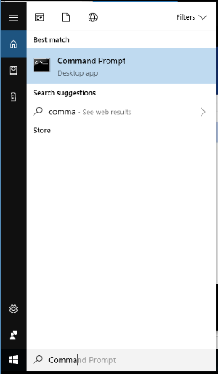

1. Type **node -v** and hit **enter**.

**Note:Underneath this line a version number should appear similar to v0.10.35. This indicates that node.js was successfully installed and it is ready to be used.**

1. Verify the installation of NPM was successful by typing **npm -v** in the command prompt. A version number resembling, 1.4.28 displays.
2. Update the **Local npm Version**.

**Note: There is almost always a newer version of npm that is different from the version you can download from the installation. Node.js does not auto update its’ npm.**

1. Run the following command to find the latest version of npm:

**npm install npm --global // Update the `npm` CLI client**

**Express Application Generator Installation**

The best way to use node.js is to install the express application generator. You can do this by performing the following steps:

1. Type the following command In the command prompt:

A picture containing object

Description generated with high confidence

1. Verify installation completes.
2. Type **-h** to view all of the command options available.

A screenshot of a cell phone

Description generated with high confidence

Once you have generated the command list, you can use the commands in the table to generate applications and web browsing capabilities.